Economics

Multiple Choice
Identify the choice that best completes the statement or answers the question.

____ 1. Which best represents the concept represented by the adage, "There is no such thing as a free lunch"?
a. | Melissa can only attend the concert if she takes her sister with her.
b. | Greg is hungry and homeless.
c. | Brian must repair the tire on his bike before he can ride it to class.
d. | Kendra must decide between going to Colorado or Cancun for spring break.

____ 2. Which of the following is most likely to generate an externality?
a. | Teachers at a local high school have pizza delivered every Friday for lunch.
b. | A young man from a small town attends medical school to become a doctor.
c. | A newlywed couple buys a TV for their family room.
d. | John buys a tractor to mow his newly purchased 5-acre lot.

____ 3. Because it is difficult for economists to use experiments to generate data, they generally must
a. | do without data.
b. | use whatever data the world gives them.
c. | select a committee of economists to make up data for all economists to use.
d. | use hypothetical, computer-generated data.

____ 4. The two loops in the circular-flow diagram represent the flow of
a. | goods and the flow of services.
b. | dollars and the flow of financial assets.
c. | inputs and outputs and the flow of dollars.
d. | capital goods and the flow of consumer goods.

____ 5. In the simple circular-flow diagram, markets consist of
a. | the market for goods and services, the financial market, and the market for the factors of production.
b. | factors of production and the financial market.
c. | the market for goods and services and the financial market.
d. | the market for goods and services and the market for factors of production.

____ 6. The field of economics is traditionally divided into two broad subfields,
a. | national economics and international economics.
b. | consumer economics and producer economics.
c. | private sector economics and public sector economics.
d. | microeconomics and macroeconomics.

____ 7. Macroeconomics is the study of
a. | individual decisionmakers.
b. | economic history.
c. | economy-wide phenomena.
d. | how firms maximize profit.

____ 8. For economists, statements about the world are of two types:
a. | assumptions and theories.
b. | true statements and false statements.
c. | specific statements and general statements.
d. | positive statements and normative statements.

Figure 3-1
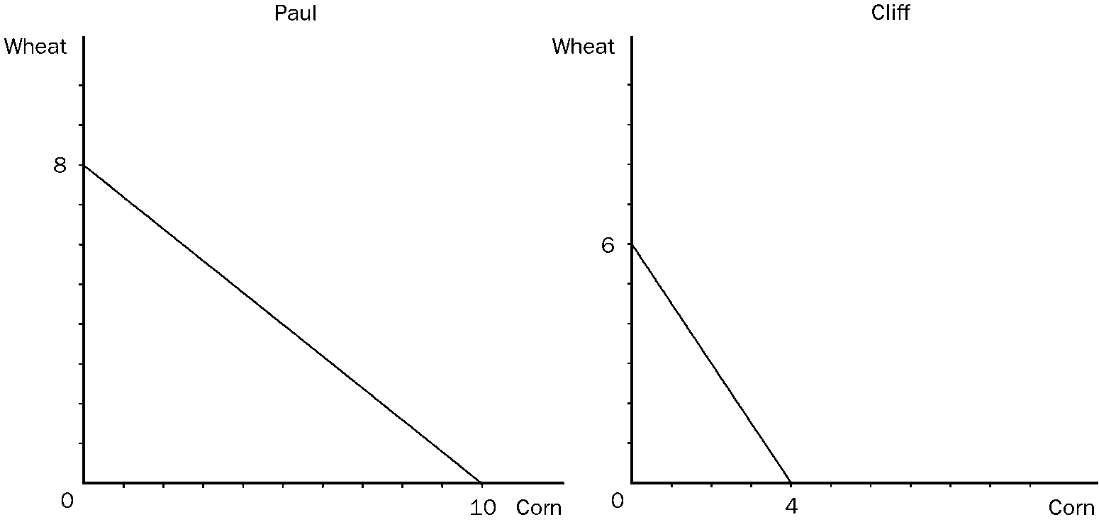

____ 9. Refer to Figure 3-1. Assume that Cliff and Paul were both producing wheat and corn, and each were dividing their time equally between the two. Then they decide to specialize in the product they have a comparative advantage in and trade 3 bushels of wheat for 3 bushels of corn. Cliff would now be able to consume.
a. | 4 bushels of wheat and 3 bushels of corn.
b. | 3 bushels of wheat and 4 bushels of corn.
c. | 3 bushels of wheat and 3 bushels of corn.
d. | 2 bushels of wheat and 3 bushels of corn.

These graphs illustrate the production possibilities available for dancing shoes to Fred and Ginger with 40 hours of labor.

Figure 3-3
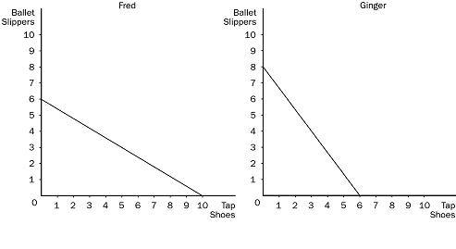

____ 10. Refer to Figure 3-3. Ginger has an absolute advantage in
a. | tap shoes and Fred has a comparative advantage in ballet slippers.
b. | both goods and Fred has a comparative advantage in neither good.
c. | ballet slippers and Fred has a comparative advantage in tap shoes.
d. | neither good and Fred has a comparative advantage in both goods.

____ 11. Trade can make everybody better off because it
a. | increases cooperation among nations.
b. | allows people to specialize according to comparative advantage.
c. | requires some workers in an economy to be retrained.
d. | reduces competition among domestic companies.

____ 12. The downward-sloping line which relates prices and quantity demanded is called the
a. | demand schedule.
b. | demand curve.
c. | quantity demanded line.
d. | quantity demanded curve.

____ 13. The market supply curve shows
a. | the total quantity supplied at any price.
b. | the average quantity supplied at any price.
c. | a ratio between price and quantity supplied for the market.
d. | a supply curve representing the 10 largest firms in the market.

____ 14. A technological advancement will shift the
a. | supply curve to the right.
b. | demand curve to the left.
c. | demand curve to the right.
d. | supply curve to the left.

____ 15. An increase in the price of a good would
a. | increase the supply.
b. | increase the amount purchased by buyers.
c. | give producers an incentive to produce more.
d. | decrease the supply.

Figure 4-7
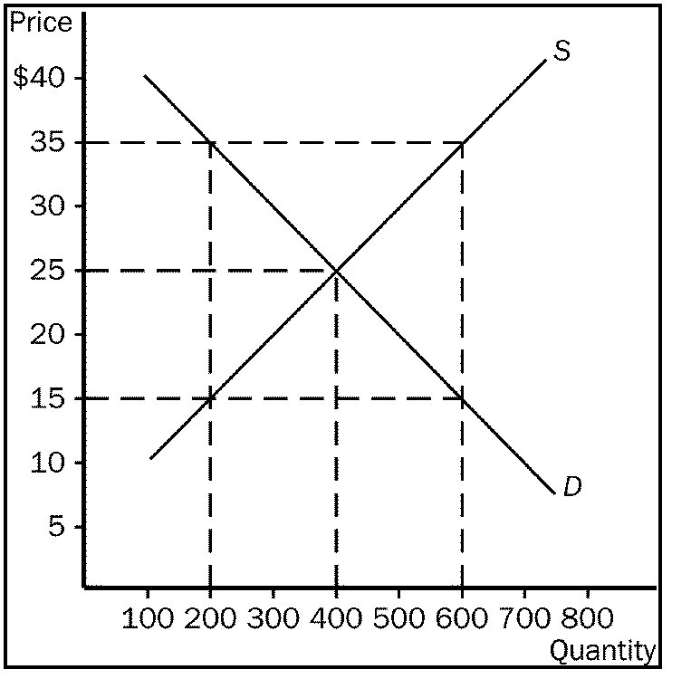

____ 16. Refer to Figure 4-7. At a price of $35,
a. | a shortage would exist and the price would tend to fall.
b. | a surplus would exist and the price would tend to rise.
c. | a surplus would exist and the price would tend to fall.
d. | the market would be in equilibrium.

Table 4-2
PRICE | QUANTITY DEMANDED | QUANTITY SUPPLIED
$10 | 10 | 60
$ 8 | 20 | 45
$ 6 | 30 | 30
$ 4 | 40 | 15
$ 2 | 50 | 0

____ 17. Refer to Table 4-2. The equilibrium price and quantity would be
a. | $4.40.
b. | $6.30.
c. | $8.30.
d. | $10.35.

____ 18. There are very few, if any, good substitutes for motor oil. Therefore,
a. | the supply of motor oil would tend to be price elastic.
b. | the demand for motor oil would tend to be price elastic.
c. | the demand for motor oil would tend to be price inelastic.
d. | the demand for motor oil would tend to be income elastic.

Figure 5-3
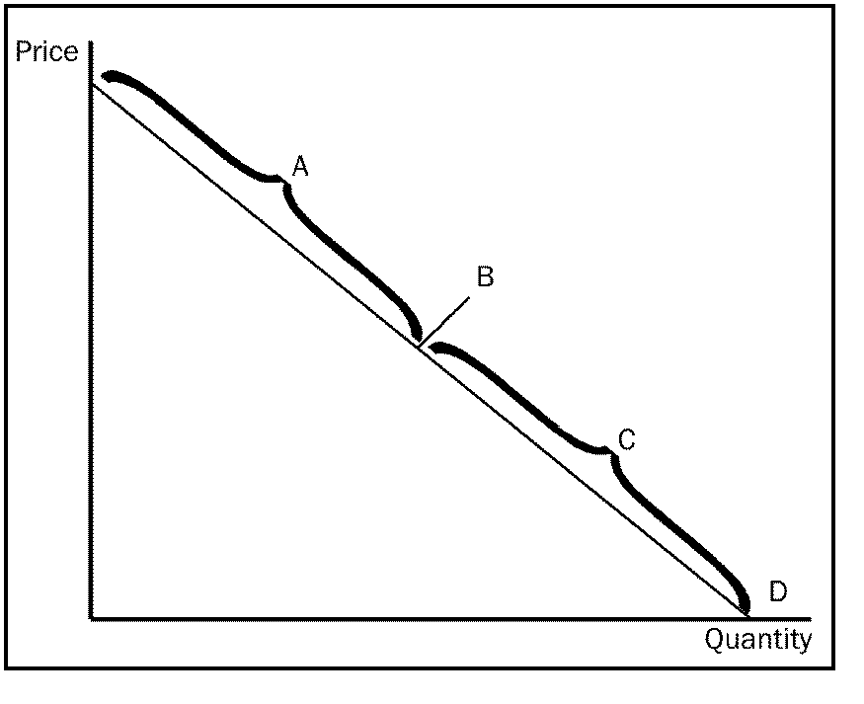

____ 19. Refer to Figure 5-3. If price falls in the A range of the demand curve we can expect total revenue to
a. | increase.
b. | decrease.
c. | stay the same.
d. | decrease, then increase.

____ 20. If the quantity supplied responds only slightly to changes in price, then
a. | supply is said to be elastic.
b. | increases in supply resulting from an increase in price will not shift the supply curve very much.
c. | supply is said to be inelastic.
d. | supply is said to be unit elastic.

____ 21. Suppose that an increase in the price of carrots from $1.20 to $1.40 per pound raises the amount of carrots that carrot farmers produce from 1.2 million pounds to 1.6 million pounds. Using the midpoint method, what would be the elasticity of supply?
a. | 2.00
b. | 1.86
c. | 0.54
d. | 0.50

____ 22. If two supply curves pass through the same point and one is steep and the other is flat, which of the following would be correct?
a. | The flatter supply curve is more inelastic.
b. | The steeper supply curve is more inelastic.
c. | The elasticity of supply will be the same for both curves.
d. | It is impossible to tell the elasticity of supply for either curve unless you are given actual numbers to compute the elasticity of both curves.

Figure 6-10
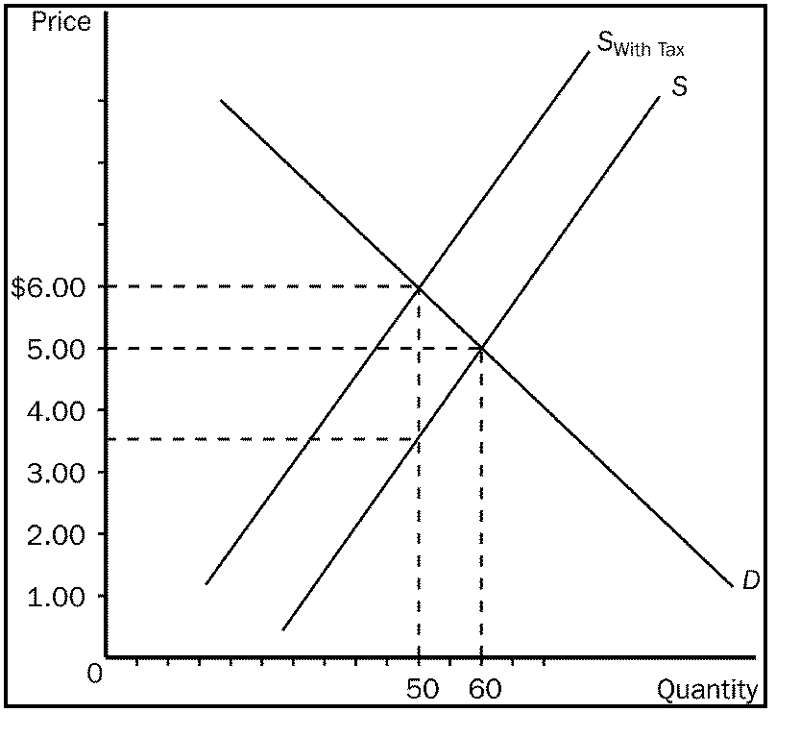

____ 23. Refer to Figure 6-10. The amount of the tax that buyers would pay would be
a. | $1.00.
b. | $1.50.
c. | $2.50.
d. | $3.00.

Figure 7-2
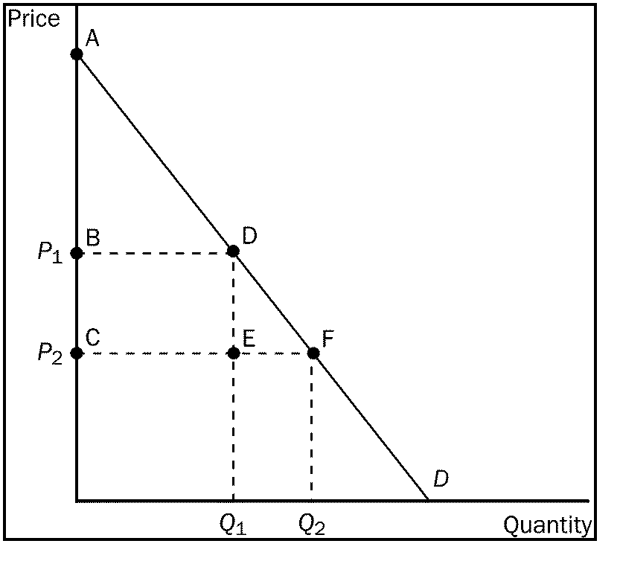

____ 24. Refer to Figure 7-2. When the price falls from P₁ to P₂, which area represents the increase in consumer surplus to new buyers entering the market?
a. | ABD
b. | ACF
c. | BCDE
d. | DEF
e. | BCFD

____ 25. If demand decreases, the price of a product, as well as producer surplus,
a. | increases.
b. | decreases.
c. | remains the same.
d. | may increase, decrease, or remain the same.

____ 26. At the equilibrium price, the good will be purchased by those buyers who
a. | value the good more than price.
b. | value the good less than price.
c. | have the money to buy the good.
d. | consider the good a necessity.

Figure 9-8
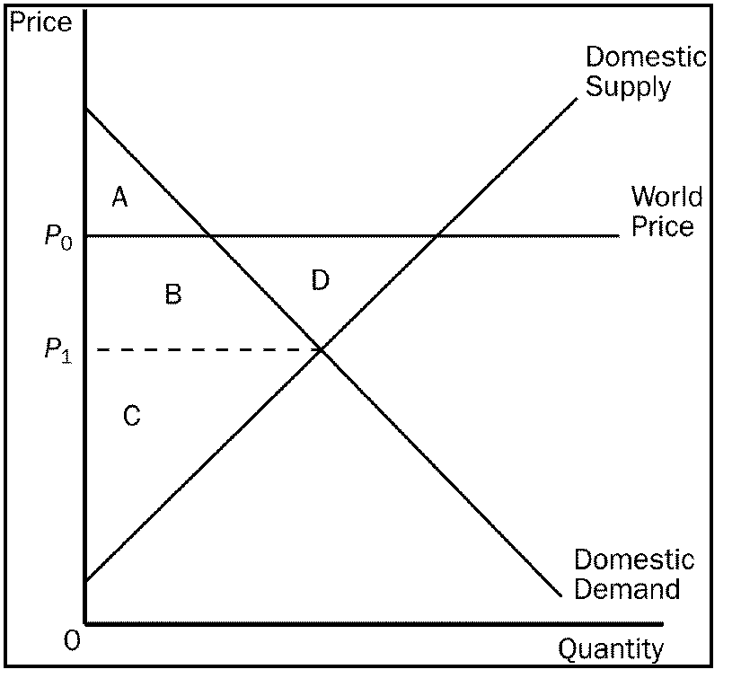

____ 27. Refer to Figure 9-8. Total surplus in this market after trade is
a. | A + B.
b. | A + B + C.
c. | A + B + C + D.
d. | B + C + D.

____ 28. A negative externality
a. | is an adverse impact on a bystander.
b. | causes the product in a market to be under-produced.
c. | is an adverse impact on market participants.
d. | is present in markets in which the good or service is undesirable for society.

____ 29. Suppose that at present there are no laws to restrict pollution produced by the widget industry. The market price of a widget is $20. If the government imposes a tax equal in value to the cost of the pollution, then firms would continue to produce widgets if
a. | the cost imposed by the pollution is less than $20 per widget produced.
b. | the private cost of producing a widget equals the cost of the pollution generated per widget.
c. | $20 minus the private cost of producing a widget is greater than the cost of the pollution generated per widget.
d. | $20 minus the private cost of producing a widget is less than the cost of the pollution generated per widget.

____ 30. Basic research is a public good because it
a. | is difficult to exclude those who might benefit from it.
b. | is used to develop public goods.
c. | always benefits developed countries at the expense of developing countries.
d. | is a rival good.

____ 31. Medicare has been the focus of many proposed reforms over the last several years because
a. | health care costs have risen more rapidly than the cost of other goods and services produced in the economy.
b. | nationalized health care systems have demonstrated that they are more efficient than private health care systems.
c. | cures for many major diseases are likely to be found in the next few years.
d. | government health care research has found that limiting access to doctors will increase the general health of the population.

The figure below depicts a total cost function for a firm that produces cookies. Use the figure to answer the following questions.

Figure 13-2
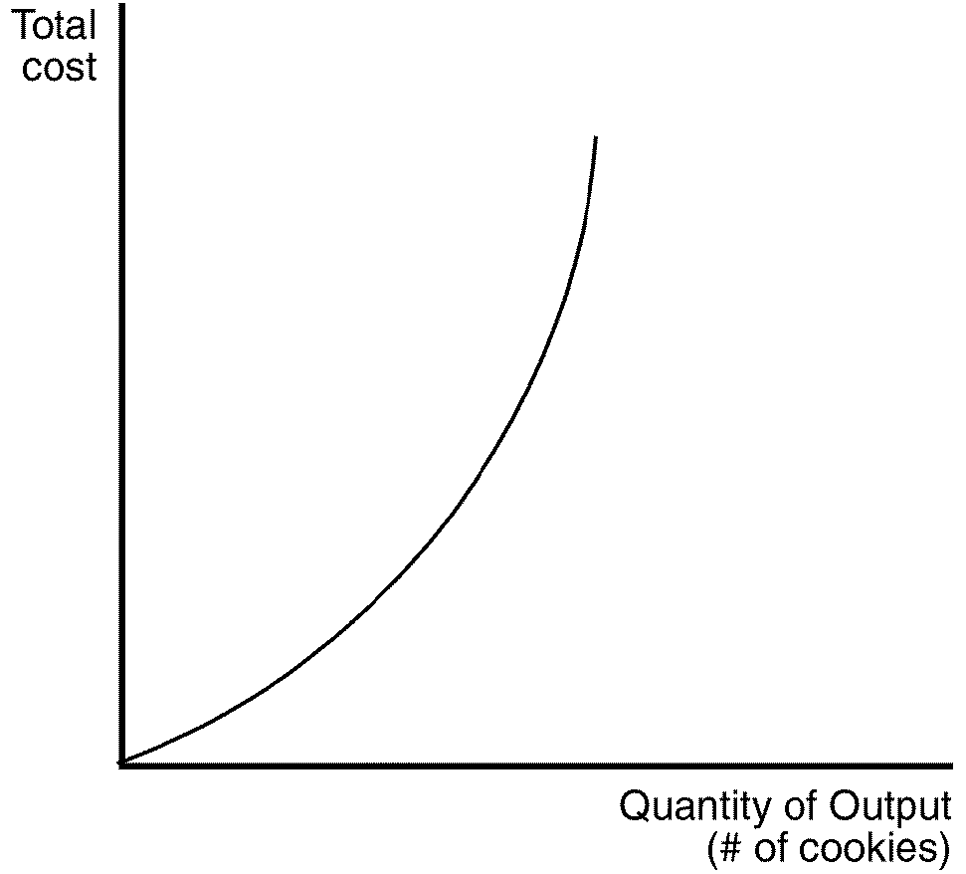

____ 32. Refer to Figure 13-2. Which of the statements below is most consistent with the shape of the total cost curve?
a. | Producing an additional cookie is always more costly than producing the previous cookie.
b. | Total production of cookies decreases with additional units of input.
c. | Producing additional cookies is equally costly, regardless of how many cookies are already being produced.
d. | Producing additional cookies becomes increasingly costly only when the number of cookies already being produced is large.

____ 33. The cost of producing the typical unit of output is the firm's
a. | average total cost.
b. | opportunity cost.
c. | variable cost.
d. | marginal cost.

Scenario 13-4
For the following questions, assume that a given firm experiences decreasing marginal product of labor with the addition of each worker regardless of the current output level.

____ 34. Refer to Scenario 13-4. Average total cost will be
a. | always rising.
b. | always falling.
c. | constant.
d. | U-shaped.

____ 35. Tom owns a factory in which he has produced TVs for five years. He has kept track of his average total cost as his level of production varies. This information is summarized below:

Output | Average Total Cost
10 | $500
20 | $400
30 | $300
40 | $400
50 | $500

From this information, we can conclude that
a. | Tom's factory exhibits both economies and diseconomies of scale.
b. | Tom's factory exhibits only diseconomies of scale.
c. | Tom's factory exhibits constant returns to scale.
d. | None of the above are correct.

Use the information in the table below to answer the following questions.

Table 14-1
Quantity | Price
1 | 13
2 | 13
3 | 13
4 | 13
5 | 13
6 | 13
7 | 13
8 | 13
9 | 13

____ 36. Refer to Table 14-1. Over which range of output is average revenue equal to price?
a. | 1 to 5
b. | 3 to 7
c. | 5 to 9
d. | Average revenue is equal to price over the whole range of output.

____ 37. If a firm in a competitive market reduces its output by 20 percent, then as a result the price of its output is likely to
a. | increase.
b. | remain unchanged.
c. | decrease by less than 20 percent.
d. | decrease by more than 20 percent.

____ 38. The fundamental cause of monopoly is
a. | incompetent management in competitive firms.
b. | the zero-profit feature of long-run equilibrium in competitive markets.
c. | advertising.
d. | barriers to entry.

____ 39. When a monopolist increases the amount of output that it produces and sells, its average revenue
a. | increases and its marginal revenue increases.
b. | increases and its marginal revenue decreases.
c. | decreases and its marginal revenue increases.
d. | decreases and its marginal revenue decreases.

____ 40. As a monopolist increases the quantity of output it sells, the price consumers are willing to pay for the good
a. | is unaffected.
b. | decreases.
c. | increases.
d. | There is not enough information given in answer the question.

____ 41. A monopolist faces the following demand curve:

Price | Quantity Demanded
$8 | 300
$7 | 400
$6 | 500
$5 | 600
$4 | 700
$3 | 800
$2 | 900
$1 | 1000

The monopolist has fixed costs of $1000 and has a constant marginal cost of $2 per unit. If the monopolist were able to perfectly price discriminate, how many units would it sell?
a. | 400
b. | 500
c. | 700
d. | 900

____ 42. As the number of firms in an oligopolistic market grows larger, the price approaches
a. | zero.
b. | marginal cost.
c. | infinity.
d. | the monopoly price.

____ 43. Which of the following will weaken OPEC's effect on the world price of oil?
(i) | Member countries abide by the regulatory policy set forth under the original collusive agreement.
(ii) | Member countries increase their own production.
(iii) | Member countries set their level of production in order to capture a larger share of the total profit available.

a. | (i) and (ii)
b. | (ii) and (iii)
c. | (i) and (iii)
d. | (i) only

____ 44. Which of the following prohibits executives of competing firms from even talking about fixing prices?
a. | Sherman Act
b. | Clayton Act
c. | Federal Trade Commission
d. | U.S. Justice Department

Use the figure below to answer the following questions.

Figure 17-2
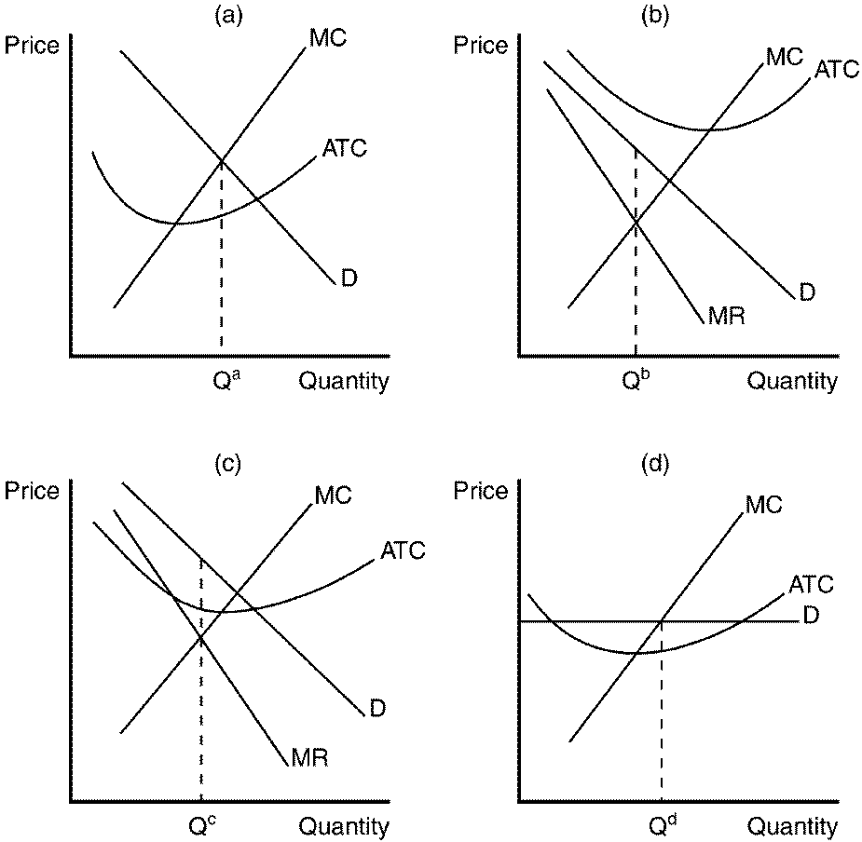

____ 45. Refer to Figure 17-2. Which of the graphs depicts a monopolistically competitive firm in long-run equilibrium?
a. | panel a
b. | panel b
c. | panel c
d. | None of the above are correct.

____ 46. When a profit-maximizing firm in a monopolistically competitive market is in long-run equilibrium,
a. | the demand curve will be perfectly elastic.
b. | price exceeds marginal cost.
c. | marginal cost is falling.
d. | marginal revenue exceeds marginal cost.

____ 47. A monopolistically competitive firm's choice of output level is virtually identical to the choice made by a(n)
a. | perfectly competitive firm.
b. | duopolist.
c. | monopolist.
d. | oligopolist.

____ 48. The factors of production are best defined as the
a. | output produced from raw materials.
b. | inputs used to produce goods and services.
c. | wages paid to the workforce.
d. | goods and services sold in the market.

____ 49. When firms are able to increase the amount of physical capital available to workers, the
a. | marginal product of labor will decrease.
b. | value of the marginal product of labor will decrease.
c. | value of the marginal product of labor will increase.
d. | final product price will increase.

____ 50. The rental price of land is
a. | the price paid for ownership of the land.
b. | the price paid for the flow of services from land over a specified time period.
c. | always more than the purchase price.
d. | All of the above are correct.

____ 51. Who receives income from capital in the United States?
a. | bank depositors
b. | bondholders
c. | stockholders
d. | All of the above are correct.

____ 52. The statement that "night shift workers make a higher wage than dayshift workers" is likely to reflect the fact that
a. | most people's preference is to work the day shift.
b. | some people just prefer to work a night shift for nonmonetary reasons.
c. | night shift jobs are generally more technically difficult.
d. | more women than men work the night shift.

____ 53. In the signaling theory of education,
(i) | schooling itself does not lead to more productive workers.
(ii) | the worker signals the employer that he is a valuable employee because he was willing to spend time to get an education.
(iii) | schooling makes employees less productive.

a. | (i) and (ii) only
b. | (ii) and (iii) only
c. | (iii) only
d. | All of the above are correct.

____ 54. Which of the following statements is true of wages, educational attainment, and gender?
a. | Male workers are compensated for attending college, while female workers generally are not.
b. | Female workers are compensated for attending college, while male workers generally are not.
c. | Both genders receive a higher wage for attending college.
d. | Neither gender receives a higher wage for attending college.

____ 55. Students who are required to finish more schooling have been found to
a. | suffer from unemployment volatility.
b. | be more likely to feel the effects of minimum wage increases.
c. | be happier with their career choices.
d. | earn a higher wage.

____ 56. Discrimination occurs when the marketplace offers different opportunities to similar individuals who differ only by
a. | level of education.
b. | attitude toward the tradeoff between labor and leisure.
c. | gender.
d. | All of the above are correct.

____ 57. Plato concluded that in an ideal society the income of the richest person would be no more than __________ times the income of the poorest person.
a. | 8
b. | 6
c. | 4
d. | 2

____ 58. If the relative price of a ticket to a concert is 3 times the price of a meal at a good restaurant, the opportunity cost of a concert ticket is the
a. | slope of the budget constraint.
b. | slope of the indifference curve.
c. | intercept on the concert axis.
d. | intercept on the restaurant axis.

Figure 21-1
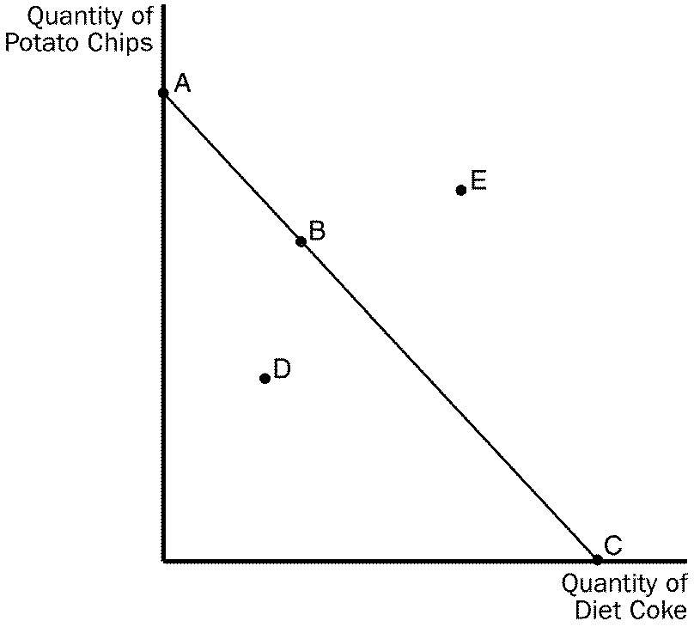

____ 59. Refer to Figure 21-1. All of the points identified on the figure represent possible consumption options with the exception of
a. | point D.
b. | point E.
c. | point B.
d. | None, all points are possible consumption options.

____ 60. Because people with hidden health problems are more likely to buy health insurance than are other people,
a. | the price of health insurance reflects the costs of a sicker-than-average person.
b. | the price of health insurance is too low, relative to the socially-optimal price.
c. | people in average health may be encouraged to buy too much health insurance, relative to the socially-optimal quantity.
d. | there is no problem of asymmetric information in the market for health insurance.

